SMGC is offering a Fun day on the Range in order to train in
Basic Pistol Marksmanship Fundamentals skills
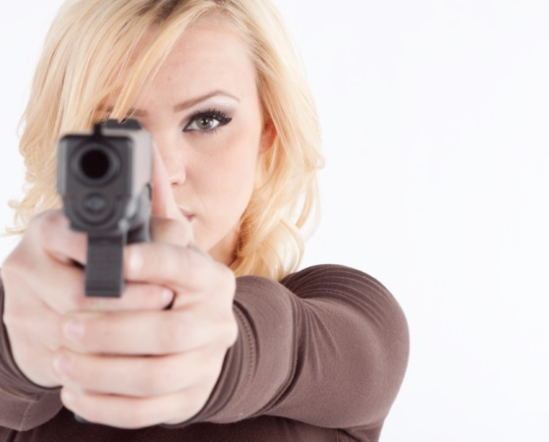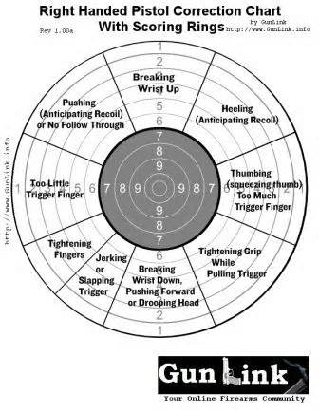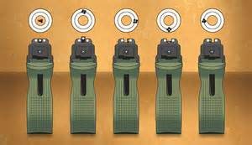
Who: This Shooting Day is open to Military members, Civilians and their Friends.
What: This day will be geared towards beginning to advanced shooters interested in Competitive Pistol Marksmanship. You will learn Pistol Marksmanship Skills including one and two handed precision fire, shooting from various positions and firing from barricades. The Minimum engagement fire will be from 7 yards and beyond, along with combination of paper and steel targets. Instructors will be members of the Santa Margarita Gun Club. All pistol calibers are allowed up to and including .45 Caliber. Pistol Holsters are allowed; however, there can be NO SHOULDER or CROSS DRAW HOLSTERS.
When: Saturday – May 18th - from 0800 hours (8:00 AM) until 1300 hours
Where: Instruction will be conducted at Range 117A aboard MCB Camp Pendleton.
Cost: The cost will be $ 30.00 per individual.
Sign Ups: In order to reserve your slot for this class, one must complete the Electronic Registration Form to be conducted on PRACTISCORE on the Santa Margarita Gun Club website at www.smgunclub.org
All persons utilizing DBIDS access will need to renew/acquire their new passes after the 15th of the Month and before the 18th to participate.
Space is limited so sign up today!!!

