United States Police & Fire Championships

“XTC”- Across the Course & 300 Yard/Meter International Prone

Large Bore Rifle/High Power Rifle Tournament Programs

- TOURNAMENT DATES: Saturday – June 2, 2018 for the “XTC” Match & Sunday – June 3, 2018 for the Prone Match.

- SPONSORING ORGANIZATIONS:
United States Police and Fire Championships Federation (USPFC)
8304 Clairemont Mesa Blvd., #107. San Diego CA 92111 USA
Tel: (858) 571-9919; FAX: (858) 571-1641; E-mail: 4info@cpaf.org

National Rifle Association (NRA), (Highpower Rifle Rules)
11250 Waples Mill Rd., Fairfax, VA 22030
Tel: (800) 672-3888
Website: www.nra.org

FOR INFORMATION CONCERNING THE TOURNAMENT:
Any Questions regarding the match can be directed to the Match Director, Harry D. Harrison at the following addresses: hdharrison@sbcglobal.net

- RANGE LOCATION: The Matches will be held at Range 103, Wilcox Range Complex, MCB Camp Pendleton, CA. Refer to SMGC web-site (www.smgunclub.org) for Camp Pendleton vehicle entry requirements and detailed driving directions to the range.

RANGE FACILITIES:
Range 103 is a 600 Yard, 140-point firing range. Sanitary facilities are of the “Port-a-Potty” variety. There are no food or drink facilities. It is highly recommended that you bring bottled drinks (non-alcoholic) and/or non-perishable food items. Alcoholic beverages are not permitted on or in the general vicinity of the firing lines. Parking will be in the dirt parking lot on the East side of the Range.

- RULES: Current USPFC Rules and National Rifle Association (NRA) High Power Rifle Rules will apply.

- OFFICIALS, PERSONNEL AND MEDICAL: Sports Coordinator and a minimum of a Three (3) Person Jury will be comprised of Board Members/Officers of the Santa Margarita Gun Club. Basic medical supplies, such as a first aid kit will be provided by the Host at the venue. Communications shall be available at the venue and preparations made in case it is necessary to summon emergency services.
- GENERAL SPORTS RULES for Large Bore Rifle:

This competition is open to all Law Enforcement and Fire Personnel (Active and Retired) of the United States of America. Purpose: To encourage friendly competition amongst current and retired members in Law Enforcement and the Fire Services who are interested in this type of shooting. Membership in the National Rifle Association, Civilian Marksmanship Program or California Rifle & Pistol Association is not required. Department Identification will be required to be shown at the site for verification of eligibility. Those persons who cannot legally participate in the shooting sports or who cannot enter a federal military reservation are not eligible to participate in this tournament. Participation DOES NOT and WILL NOT automatically authorize entrance onto MCB Camp Pendleton, CA.

To ensure authorized entry onto the base, eligible competitors must ensure you do the following:
- Possess a Department of Defense Vehicle Sticker authorizing you to enter the military instillation OR
- Pre-enter the matches desired utilizing the Electronic Entry Registration on the club’s web site AND
- Have in your possession the following items:
  - Current and a Valid Driver’s License and or other picture Identification
  - Current Vehicle Registration
  - Current Proof of Vehicle Insurance
- Completed the Electronically Entry Registration into the scheduled matches.

- ENTRIES – Electronic (Two Step Process): 1. ADVANCE ENTRIES ARE REQUIRED ON THE USPFC Web Site (First) for all Law Enforcement and Fire Services competitors.
2. Electronic Entry is also required on the SMGC Web site for squadding and category purposes: Individual competitors are required to indicate their intent to participate using the electronic Match Registration Form available on the SMGC website (www.smgunclub.org) for this event.

MCB Camp Pendleton Security Regulations require the match sponsor to notify the appropriate Base agency of Non Department of Defense (DoD) persons participation in the Match on the Wednesday preceding the Matches. This notification is generated by the received match registration form. Therefore entry onto MCB Camp Pendleton may be denied to those persons who do not indicate their intent to participate or observe using the Electronic Match Registration Form. Additionally, persons who have expired driver’s licenses will not be granted entry onto Camp Pendleton.

A. Entry into Camp Pendleton for those without a DoD Sticker should be through one of the following three gates:
a. The Main Gate - Oceanside,
b. The Las Pulgas Gate or
c. The (San Luis Rey entrance) Rear Gate

B. Entry Through the Fallbrook Naval Weapons Station – is restricted to those who have a current DoD Sticker or Military Identification.

Please allow a 30-45 minute process to go from any of the above mentioned gates to the Range. Please go to the SMGC website (www.smgunclub.org) prior to leaving for Camp Pendleton for the most up-to-date information on Matches or activities aboard Camp Pendleton.

- ENTRY FEES: All individual Entries must be paid in advance to the USPFC.
- ENTRIES CLOSE: Individual Entries close on Wednesday May 23, 2018 at 7:00 A.M. (PST).

- POST ENTRIES: Entries RECEIVED after 7:00 A.M. (PST), Wednesday, May 23, 2018 on the SMGC Website are considered late entries and WILL NOT be accepted. This is due to Base Access Rosters which must be submitted to the Base Security Management Office.

- ENTRY LIMIT: 120 Individual Entries.

- RIFLE MATCH START TIMES: 9:00 A.M. on Saturday- June 2, 2018 and 9:00 A.M. on Sunday- June 3, 2018. A Mandatory Safety Brief will be held at 8:00 A.M. at the Covered Bleacher “Thunderdome” Area. Those missing this Safety Brief will not be allowed to compete.

- CLASSIFICATION OF COMPETITORS:
The NRA High Power Rifle Classification System will be used for this tournament. Assigned classification (Rule 19.6) or a temporary classification (Rule 19.4) may be used, if applicable. Non-NRA members and NRA members who are unclassified or cannot provide classification information will compete in either the Unclassified or by their assigned classification by the USPFC.

- CLASSIFICATION OF RIFLES:

The Following RIFLE TYPES ARE ALLOWED in the following Matches:

“XTC” – Across the Course Match (200, 300 and 600 Yards) - Saturday- June 2, 2018
ONLY One Rifle Type Allowed per competitor
- Service Rifles
- Match Rifles

- Service Rifles – Modern or Previous Military Rifles which were used by the U.S. Armed Forces
(NRA Rule 3.1) Service rifles (USA – AR Type Rifles) are authorized to have a sight optic of no greater than 4.5 X Power. Rifles may also have a collapsible stock.
Optical Sights For Service Rifles. For several years, the CMP and NRA have recognized that optical sights are the wave of the future for Service Rifle shooting. Military recruits today do all of their training with optical sighted rifles. Service Rifle rules have traditionally tried to keep abreast of military rifle and training developments so opening Service Rifle shooting to optical sights became an inevitable change.

The current rules permit M16/AR15-type rifles to have optical sights with a maximum magnification of 4.5X power. Legal scopes can be fixed power or variable, but the maximum power of variable scopes may not exceed 4.5X. Scopes will have to be manufactured with a maximum 4.5X magnification and have an objective lens no larger than 34 mm. There will not be a separate class for scope-sighted service rifles. Instead, competitors will have a choice of using either a scope-sighted rifle or a metallic sighted service rifles.

Since accurized Service Rifles first came into popular use, in the 1950’s and 1960’s, those rifles, whether M1’s, M14’s or M16’s and their commercial equivalents, have been rigidly defined.

Legal M16-type service rifles have to retain the external profile of an M16A2 or M16A4 rifle and could only have modifications that were explicitly permitted in the rules. All this has changed in 2016.
The current service rifle rules state that M16/AR15-type Rifles must be “an M16 U. S. Service Rifle or a similar AR15 type commercial rifle that is derived from the M16 service rifle design” and there will be far fewer specific restrictions. Restrictions will simply require M16/AR15-type rifles that:
• Are chambered for the 5.56 x 45 mm (.223) NATO cartridge.
• Are designed or modified for semi-automatic fire only.
• Have either a gas-impingement system or a piston-operated gas system.
• Have a barrel that is no longer than 20 inches, with or without a flash suppressor (16” barrels are permitted).
• Use one upper receiver and barrel for the entire match.
• Have a trigger pull of at least 4.5 pounds.
• Use standard service magazines or commercial equivalents that do not contain added weights.
• Have a fixed or collapsible butt-stock that may vary in length and even be adjusted between firing stages. Butt-plates or cheek-pieces may not, however, be adjustable.
• Have a standard A1 or A2 pistol grip.

This will open the way for competitors to use a wider variety of M16/AR-16-type rifles and there is NO weight limit for scope-sighted rifle.

M14 or M1A Service Rifle Rules - The optical sight option is ALSO available for these rifles.
Examples below are U.S. Service Rifles; M-1 Garand (For this competition .30-06 is not allowed on this range); M-14/M1A1 and M16/AR15A2/M4. Service Rifles may be built around any manually loaded actions designed to safely fire either of the permitted cartridges. Service Rifles typically have metallic sights; however, Rifle Optics are allowed to be placed on the rifle provided they are not more than a (4.5 X) power. Any Service Rifle used shall have a trigger pull of no less than 2.04 kilograms (4.5 pounds).

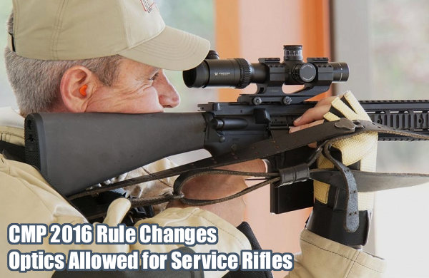
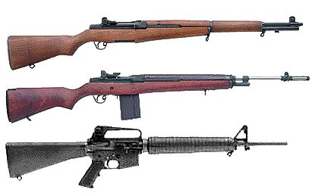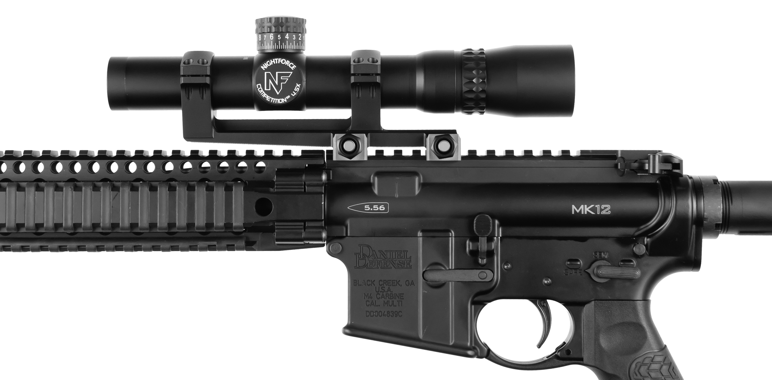

M14 or M1A Service Rifle Rules. For competitors who prefer to use M14 or M1A rifles, those rules are somewhat simplified, but remain essentially the same. The optical sight option is not available for these rifles.

NRA High Power Rifle Classifications (NRA Rule 3.1 Service Rifle) - As issued by the U.S. Armed Forces, or the same type and caliber of commercially manufactured rifle, having not less than 4 1/2 pound trigger pull, with standard type stock and standard type leather or web sling. External alterations to the assembled arm will not be allowed. The application of synthetic coatings, which includes those containing powdered metal, to the interior of the stock to improve bedding is authorized provided the coating does not interfere with the function or operation of safety features. The front and rear sights must be the standard or National Match design, but may vary in dimensions of rear sight aperture and front sight blade. The rear sight aperture may be hooded. The internal parts of the rifle may be specially fitted and include alterations that will improve the functioning and accuracy of the arm, provided such alterations in no way interfere with the proper functioning of the safety devices as manufactured. The rifle must be so modified as to be incapable of automatic fire without removing, replacing, or altering parts. The gas system must be fully operational.

(a) U.S. Rifle, Caliber .30 M-1, or caliber 7.62mm M-1 - A device consisting of a modified cartridge clip that is intended to permit single loading from the clip into the chamber during slow fire is considered an internal alteration to improve functioning and is permissible under this rule.

(b) U.S. Rifle, Caliber 7.62 mm M-14 - Must be no more than 2 inches wide at a point immediately to the rear of the front band, no more than 2.5 inches wide at the front and rear of the receiver, and have a continuous taper from receiver to front band. Width at receiver may be carried through to the butt plate, which may be the flat M-1 or hinged M-14 plate, which will be used only in the folded position. In all courses and in all positions the standard 10 or 20-round box magazine or a reduced capacity magazine of the same external dimensions will be allowed. For stock dimension see diagram in illustrations.

(c) U.S. Rifle, Caliber 5.56mm M-16 series –
- Must be chambered for the 5.56 x 45 mm NATO (.223) cartridge,
- The gas operation system must be fully operable and adhere to the original M-16 rifle design (i.e. Stoner design, gas impingement system) or have a piston-operated gas system.
- The receiver must be separately machined form the handguard; the two parts must be separable.
- The barrel may be no longer than 20 inches; flash suppressors are not required, but if the barrel has a flash suppressor, it shall not be included in the barrel length measurement.
- Upper receivers and barrels may not be changed during the firing of any event.
- Metal or synthetic (polymer) magazines, standard issued or commercial equivalent, with standard service 20 or 30-round box magazine dimensions must be attached during the firing of all courses and in all positions. A 10-round magazine with the extra external dimensions as a standard service 20-rond box magazine may be used. A dummy magazine with a ramp for single shot loading may be used if this magazine has the same external dimensions as the standard service 20-round box magazine. Magazines may not contain added weights.
- The rifle may have an optical sight (reflective sights are considered optical sights) with a maximum power of 4.5 X installed on the receiver. Variable scopes with a maximum of 4.5 X are permitted. Only commercially manufactured scopes that were produced with a maximum magnification of 4.5 X and that have a maximum objective lens of 34 mm may be used. If an optical sight is used, the same optical sight must be used in all stages of a course of fire (changing sights is not permitted). The centerline of an optical sight shall be no higher than 3.5 inches above the centerline of the bore.
- Alternatively, the rifle may be equipped with issue-type metallic front and rear sights. Metallic sights, if used, must have an M16 type sight design with the rear sight in the carry handle and the front sight in the standard M-16 location.
- Butt-stocks may vary in length and be either fixed or collapsible. Collapsible or adjustable length stocks may be adjusted during an event, but butt-stocks that allow for other adjustments such as check-piece height or butt-plate location may not be used.
- Only standard A1 or A2 type pistol grips may be used.
- Quad rails or similar hand guards may be used.

(d) U.S. Rifle, Caliber 7.62 mm M-110 series - In all courses of fire and in all positions the standard 20 round box magazine or a reduced capacity magazine of the same external dimensions will be attached. The flash suppressor may be removed or the rifle may be manufactured without a flash suppressor. Barrel length may not exceed 20 inches, as measured to the end of the rifling in the barrel. The front sling swivel must be attached to the end of the handguard, and must remain in the 6 o=clock position no more than ½ inches from its original location. The sights must be of the standard design found on the M-16 series of firearms. Rear sight windage and elevation adjustments may be modified to allow finer adjustments. Plastic covers may be used on the mounting rails on the handguard.

(e) Any rifle or modified rifle not covered by NRA Rule 3.1, but permitted by CMP Rules is considered a service rifle in NRA sanctioned competition.

- NRA Match Rifle (NRA Rule 3.3) - A center fire rifle with metallic sights and a magazine capable of holding not less than 5 rounds. A center fire rifle with Iron / Metallic Sights or Optics (No Magnification Restriction). This rifle has no restrictions regarding weight of the rifle or trigger; however, the trigger must be safe. Examples Below: Tubb 2000 Rifle / McMillian Alias Rifle and AR Flat Top with Iron Sight and Scope Sights.
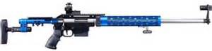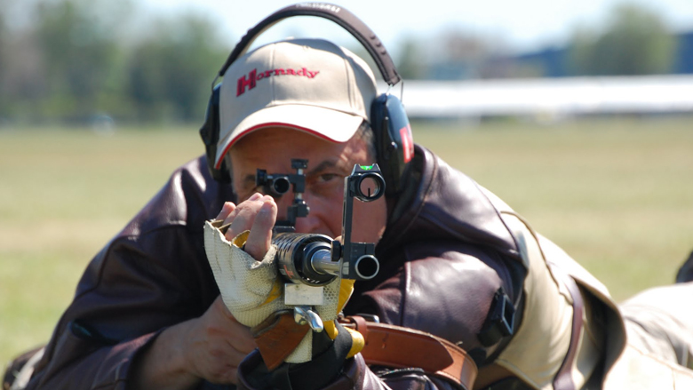

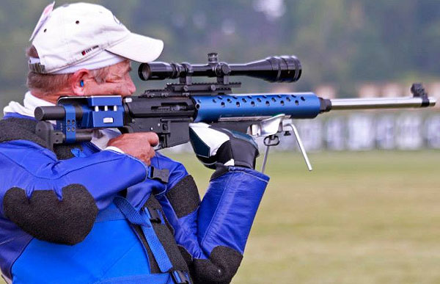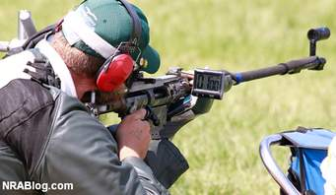

(a) See Rule 3.14, Palm Rest.

(b) A service rifle may be used as a match rifle unless otherwise stated in the program. Any service rifle used as an NRA Match Rifle shall conform to Rule 3.1 as applies to trigger pull.

(c) Semi-Automatic rifle. M-16 or commercially equivalent rifles, configured or customized as NRA Match Rifles are exempt from the 4 1/2 pound trigger weight requirement.

(d) Any semi-automatic rifle that has an original factory design receiver/frame in excess of 3 1/4 inches below the center line of the bore may be used as an NRA Match Rifle.

Rifles may be either Bolt Operated or Semi-Automatic Rifles with Telescopic Sights with a magazine capacity of not less than 5 rounds. Ammunition will be restricted to either .223 caliber or .308 caliber.

A Rifle should be capable of performing a mandatory reload (i.e. magazine exchange) during the rapid fire stages in order to fire the ten rounds per string of fire; however, if a rifle can only hold 5 rounds it will still be allowed to be used; however, the competitor needs to attempt to fire a total of 10 rounds if they want to receive the highest possible score.

- XTC MATCH SCHEDULE / COURSE OF FIRE:

Individual - High Power Across the Course “XTC” – Regional Match Course 800 Point Aggregate

Match # | Stage | Distance | Sighter Shots |  | Record Shots |  | Target | Points
 |  |  | # of Shots | Time Limit | # of Shots | Time Limit
1 | Slow – Offhand | 200 Yards | 2 | 2 Min | 20 | 20 Min | SR | 200
2 | Rapid –Sitting | 200 Yards | 2 | 2 Min | 20 | (2-10 Shot Strings of Fire) 60 Sec Per 10 Rd String | SR | 200
3 | Rapid –Prone | 300 Yards | 2 | 2 Min | 20 | (2-10 Shot Strings of Fire) 70 Sec Per 10 Rd String | SR-3 | 200
4 | Slow – Prone | 600 Yards | 2 | 2 Min | 20 | 20 Min | MR-1 | 200
Aggregate 800 Point - 80 Shot Regional Match Course - Match # 5 |  |  |  |  |  |  |  | 800

- XTC INDIVIDUAL AWARDS:

Individual Medals will be awarded to the top three in each category and equipment type (Match Rifle and Service Rifle). These rifle categories will be treated separately.

Match Rifle | Service Rifle
Gold Medal | Gold Medal
Silver Medal | Silver Medal
Bronze Medal | Bronze Medal

- 1st Place awarded
- 2nd Place awarded
- 3rd Place awarded

Categories & Classes for Aggregate Match (Individual Awards):

Separate competitor categories (High Master, Master, Expert, Sharpshooter, Marksman and Unclassified) will be established for Match Rifle and Service Rifle ONLY.

USPFC XTC Match – Across the Course 800 Aggregate – Possible Score of 800 x 80

Classification Average “USPFC” Scores
High Master 97.00 and above 776 - 800
Master 95.00 to 96.99 752 - 775
Expert 92.00 to 94.99 712 - 751
Sharpshooter 85.00 to 89.99 672 - 5711
Marksman Below 88.00 671 and below

Official recognition of the overall tournament classification winners will be recorded in the Tournament Bulletin for the total tournament aggregate score to include the distinction of competitor category (High Master, Master, Expert, Sharpshooter, Marksman and Unclassified) and equipment type (Match Rifle and Service Rifle):

1st Place | High Master | Master | Expert | Sharpshooter | Marksman | Unclassified
2nd Place | High Master | Master | Expert | Sharpshooter | Marksman | Unclassified
3rd Place | High Master | Master | Expert | Sharpshooter | Marksman | Unclassified

Team Match - High Power Across the Course “XTC”:

The TEAM MATCH will consist of the grand aggregate scores of both shooters on the team, regardless of the type of rifle(s) used by each individual competitor.

CLASSIFICATION OF TEAMS:

The XTC Team Classifications will be divided into two classes:

“A” Class Team: 2 Persons/Shooters from the Same Agency.

“B” Class Team: 2 Persons combined agencies or pool players.

XTC Categories & Classes for Aggregate Match (Team Awards):
Team Awards will be regardless of rifle categories (NRA Match or NRA Service Rifle) used within the individual competitor categories.

“A” Class Team | 1st Place –Gold Medal | 2nd Place-Silver Medal | 3rd Place-Bronze Medal
“B” Class Team | 1st Place –Gold Medal | 2nd Place-Silver Medal | 3rd Place-Bronze Medal

Official recognition of the overall tournament classification winners will be recorded in the Tournament Bulletin for the total tournament aggregate score regardless of competitor category and/or equipment type. Awards will be distributed at the range.

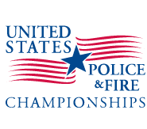

United States Police & Fire Championships

300 Yard/Meter International Prone
300 Yard/Meter International Prone Match (300 Meter reduced to 300 Yards - Prone)

Large Bore Rifle/High Power Rifle Tournament Program
ONLY One Rifle Type Allowed per competitor

- TOURNAMENT DATES: Sunday – June 3, 2018 for the Prone Match.

- GOVERNING COMPETITION RULES: Current USPFC Rules, International Confederation of Fullbore Rifle Associations (ICFRA) and National Rifle Association (NRA) Rifle Rules will apply. If there are conflicts between these rules the USPFC Rules will take precedence over the games.

USPFC ABRIDGED RULES-RIFLE-Large Bore 2018 and this Tournament Program.

International Confederation of Fullbore Rifle Associations (ICFRA) (Technical Rules for F-Class Shooting) Web-Site: http://icfra.com

National Rifle Association (NRA), (International Full Bore Prone Rifle Rules)
11250 Waples Mill Rd., Fairfax, VA 22030 Tel: (800) 672-3888
Web-Site: http://competitions.nra.org/official-nra-rule-books.aspx

- CHECK-IN PROCEDURES:
All competitors must check in at the Match Statistical Office for administrative processing.
The Statistical Office will be open at 7:00 AM (0700 hours) on the morning of the tournament.

Competitors are required to complete the administrative processing, show department identification, and receive their squadding assignments before they can participate.

- MANDATORY RANGE SAFETY & ENVIRONMENTAL BRIEFING:
After completion of administrative processing, all competitors must report to the Covered Bleacher “Thunderdome” Area not later than 8:00 AM to attend the mandated range safety and environmental briefing. Competitors not attending the mandated briefing will not be allowed to compete. Entry fees will be refunded less a $10.00 processing charge.

- TARGET PULLERS: Competitors will be required to pull targets. ALL competitors are expected to take turns performing this service. If unable to perform this task, the shooter must provide a viable puller instead. Paid Pullers may be available; however, Paid Pullers are not guaranteed.

- TARGETS: Official NRA (C-3) Targets and repair centers will be used.

- COMPETITOR PARKING AREAS: (Range 103) - Overnight Competitor parking is permitted in the designated dirt parking lot of Range 103. ALL Competitors are required to park their vehicles in the dirt parking lot of Range 103, to the East of the range.

- SAFETY EQUIPMENT: Hearing Protection, Eye Protection, and Empty Chamber Indicators (ECI) or Empty Chamber Flags are mandatory. ECI’s may be purchased at the range for a cost of $ 2.00.

- OTHER EQUIPMENT: Cloth, canvas or leather shooting jackets may be used. Standard military-issue web or leather slings or slings of this same type are permitted. Shooting gloves or mitts, ground cloths or shooting mats may be used. Shooting kits may be placed on the firing line provided they are not forward of the competitor or the firing line and do not interfere with other competitors. Since no competitor vehicles are allowed forward of the 600 yard line, competitors will be required to transport their equipment to the various yard lines. It is suggested for competitors to utilize appropriate methods (i.e. carts or wagons) to transport their equipment to the various yard lines. A shuttle service will be available to competitors who need assistance.

- SHARING RIFLES & EQUIPMENT IS ALLOWED: Competitors are allowed to share rifles and/or equipment. Prior notification to the Match Director is required and necessary to allow proper squadding to facilitate the sharing of gear.

- SIGHTS: Match Rifle (Iron or Telescopic) sights & Service Rifle, Metallic (Iron) sights or Optical sights (4.5X maximum) are allowed.

- AMMUNITION: Competitors must supply their own ammunition. Any safe center-fire ammunition, 5.56 x 45mm (.223 caliber) or 7.62mm (.308 caliber), may be used. Tracer, incendiary or armor piercing ammunition is prohibited (Rule 3.17(b) applies). It is highly suggested that competitors bring a minimum of 100 rounds to allow for any alibis during the rapid fires to include sighter shots.

- SIGHTING SHOTS: Sighting shots are allowed for each authorized Match and may be taken at shooter’s option. Sighters must be declared and recorded before “record shots” are fired. Sighting shots not taken will be recorded as an “M” in the spaces reserved for Sighting Shots on the scorecard. Refer to the Courses of Fire Section.

- CHALLENGES: A fee of $2.00 is required and payable upon requesting the challenge. If the challenge is denied, the fee will be forfeited.

- CHALLENGE PERIOD: The challenge period will end ½ hour after the posting of the last match results.

- CLASSIFICATION OF COMPETITORS:
The NRA High Power Rifle Classification System will be used for this tournament. Assigned classification (NRA Rule 19.6) or a temporary classification (NRA Rule 19.4) may be used, if applicable. Non-NRA members of representative countries and those who are unclassified or cannot provide classification information will compete in either the “Unclassified” category or by their assigned classification by the USPFC. Competitors are expected to present/show their Rifle Association’s Classification Card or Temporary Classification at the Rifle/Equipment Inspection(s).

- COMBINING OF CLASSIFICATIONS: (NRA Rule 19.8.1) When there are insufficient entries in any class to warrant an award in that class according to the match program conditions, the individual or team concerned may be moved by the Tournament Match Director to a higher class provided this change is made prior to the individual or team concerned having commenced firing in a tournament.

RIFLE TYPES ALLOWED:
- Service Rifle
- Match Rifle
- Sniper/F-Class - Tactical / Restricted Rifle (F-TR) (NRA International Fullbore Rule 3.4 (b)) rifles are allowed. A typical Police Department Sniper Rifle (in .308 or .223 Cal.) should fit into this (F-TR) category.

- Rifles that exceed their appropriate NRA specifications will be disqualified; scores fired disallowed, and match fees forfeited. All rifles will be restricted to the chambers of unmodified .308 Winchester/7.62mm NATO or unmodified .223 Remington / 5.56mm x 45 NATO cartridge cases.

The rifle must be fired off a bipod, rigidly attached to the rifle’s forend, and/or a sling may be used. Any bipod, meeting the definition of a bipod, may be used but its weight must be included in the rifle’s overall weight. Any safe, manually operated trigger is permitted. Any sighting system is permitted, but it must be included in the rifle’s overall weight. There is NO Restriction on the magnification used.

(1) The rifle’s overall weight, including all attachments such as sights, sling and bipod, must not exceed 8.25 kilograms (18.18 pounds). An “attachment” also includes any external object, other than the competitor and their apparel, which recoils or partially recoils with the rifle, or which is clamped, held, or joined in any way to the rifle for each shot, or which even slightly raises with the lifting of the rifle from its rest/firing point.

(2) The rifle must be fired in the prone position from the shoulder of the competitor using rifle rests.

For F-TR Rifles, all attachments must be compliant with current ICFRA rules.

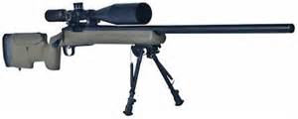
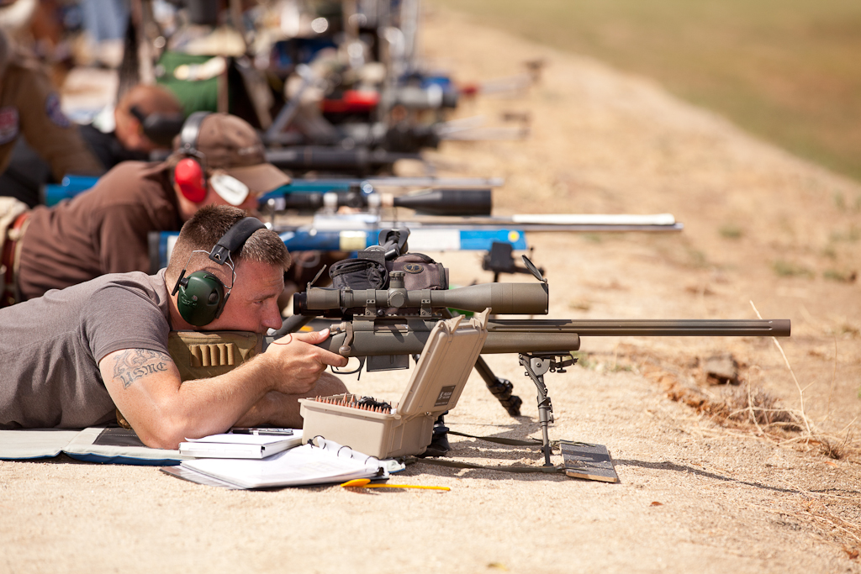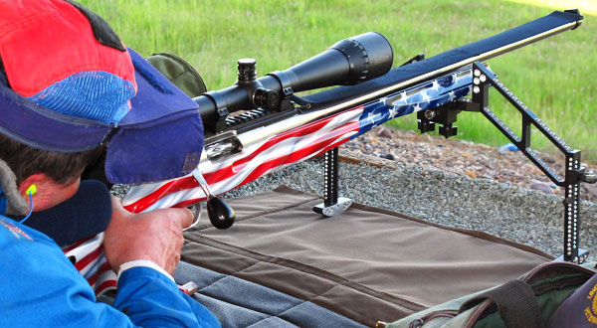

Bags may be used at the rear end of the rifle to rest on, but NO SAND BAGS are allowed on the front.

Where conflicts between ISSF/ICFRA/NRA guidelines and USPFCF rules occur (i.e. awards formula, eligibility of competitors and substitutions after competition begins) the USPFC rules will be used.

Ammunition: Competitors must provide their own ammunition for all classifications and categories. Due to the USMC SDZ (Surface Danger Zone) qualifications, NO Round greater than a .308 Caliber will be allowed.

- Sniper/F-Class Tactical/Restricted Rifles:
Only permitted cartridges for these Rifles are the .308 Winchester/7.62 x 51mm commercial or metric equivalents and .223 Remington/5.56 x 45 mm commercial or metric equivalents.
Tracer, incendiary or armor piercing ammunition is prohibited.

CLASSIFICATIONS (Individuals): Refer to USPFC Abridged Rules; Page 1, 2, and 4, additionally, the NRA High Power Rifle Classification System will be used for this tournament. Assigned classification (Rule 19.6) or a temporary classification (Rule 19.4) may be used, if applicable. Shooters who are unclassified or cannot provide classification information will compete in the “Unclassified” category or by their assigned classification by the USPFC.

- CLASSIFICATIONS OF TEAMS (See Abridged USPFC Rules):

Team classifications will be established in accordance with the current NRA System (NRA Rule 19.12).

Unclassified Shooters at the Start of this Competition will be assigned as a Master Class Shooter (for Team Match Classification Purposes ONLY) with a Value of (4).

Once the team member’s names have been provided by the team captain, each member will be assigned their respective value. High Master = 5; Master/Unclassified = 4; Expert = 3; Sharpshooter = 2; Marksman =1.

Teams are classified by computing the “team average” based upon the classification of each firing member of the team. The team’s average is taken by adding the total number, then dividing the total number by the number of firing members of the team. Any fractional figure in the team average of a half (.5) or more will place that team into the next higher class. The team average will establish the classification of the team as a unit, but will not affect in any way the individual classification of each of the team members.

The Team Classifications will be divided into two separate Divisions: Division A or Division B.

Team Matches

Division A – Sling &/or F-Class Rifles (High Master, Master, Expert) Teams

Division B – Sling &/or F-Class Rifles (Sharpshooter, Marksman) Teams

The divisions will be separated into the following Class Teams:

“A” Class Team: will consist of 2 persons from the Same Agency

“B” Class Team: will consist of 2 person combined agencies or pool players

“C” Class Team: will consist of 2 persons from the same agency and/or combined agencies or pool players where BOTH Shooters fired using a Sniper/F-Class Tactical/Restricted (F-T/R) Rifle.

A Class Team B Class Team C Class Team (Bi-Pods Only)
| | |
Same Agency Pooled Agencies Same Agency OR Combined/Pooled
Same or Different Rifles Same or Different Rifles ONLY Using Sniper/F-TR Rifles

The TEAM MATCHES will consist of the combined Grand Aggregate Score fired for record DURING the Individual Match Courses of Fire

The individual’s team scores will be out of a possible 600 x 60 points. Two individuals will make up the team, (i.e. Shooters A, B,). Each will have their individual Scores added together, in order to make their TEAM Aggregate score.

Example No 1: Team Match For Team “X” (Pooled Agencies, Same/Different Rifles)
Shooter A - fires a 550 x 20, out of a possible: 600 x 60 (Shooter A is a F-TR Rifle - High Master) = 5
Shooter B - fires a 445 x 10, out of a possible: 600 x 60 (Shooter B is a Service Rifle - Marksman) = 1

Example No 1: The Team Aggregate Score would be: 995 x 30, out of a possible: 1200 x 120.

The Team Division - is determined by the average of the individual shooter’s ratings.
(5) High Master + (1) Marksman. Those points (5+1) total to equal 6.

6 is then divided by 2 (the Total number of Shooters) which equals 3.0
This places the team into an Expert Rating (3.0 +) and therefore would be placed as a Division “A” Team,
“B” Class Team (Pooled Agencies, Same or Different Rifles).
The Team’s Aggregate score will be made up regardless of an individual’s respective rifle category.

International “Prone” Match - Course 600 Point Aggregate - 300 Yards (SUN)

Stage # | Stage Description | Distance | Sighter Shots |  | Record Shots |  | Target | Possible  Points
 |  |  | # of Shots | Time Limit | # of Shots | Time Limit
1 | Slow Fire | 300 Yards* | Unlimited | 10 Min | 20 | 20 Min | C-3 Reduced  Targets | 200
2 | Slow Fire | 300 Yards* | 2 | N/A | 20 | 22 Min | C-3 Reduced  Targets | 200
3 | Slow Fire | 300 Yards* | 2 | N/A | 20 | 22 Min | C-3 Reduced  Targets | 200
4 | Aggregate Score (Stages 1, 2 & 3) |  |  |  |  |  |  | 600

300 Meters is the normal standard for this competition. Targets normal used are in accordance with (ISSF Rule 6.3.4.1). Due to Range Constraints, 300 Meters* is not available; however, 300 Yards is available. Therefore the 2018 USPFC Prone Match will be fired at 300 Yards. As such, Targets will be Reduced Targets from 300 Meters to 300 Yards. All rifle categories (Sling & F-Class) will fire on the same target (C-3).
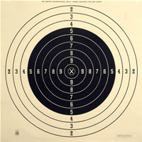

C-3 Target which will be USED

Target is a decimal target with values from 2 thru 10. An X-ring is located within the 10 ring and has a value of 10; however, “X’s” will be recorded and used as a tie breaker. This Target is assigned by (USPFC Rules).

- INDIVIDUAL AWARDS for the Prone Match:

- The Top three in each individual category and equipment type will be awarded medals.

(Match Rifle (Sling), Service Rifle (Sling) and F-TR (Bi-pod).

- The Top three in each individual category and equipment type will be awarded medals.

Iron/Scope(4.5X) / Sling | Iron/Scope / Sling | Scoped Rifle / BIPOD
Service Rifle | Match Rifle | Sniper/F-TR Rifle
Gold Medal | Gold Medal | Gold Medal
Silver Medal | Silver Medal | Silver Medal
Bronze Medal | Bronze Medal | Bronze Medal

Rifle Types
- 1st
- 2nd
- 3rd

1st Place Medals | High Master | Master | Expert | Sharpshooter | Marksman | Unclassified
2nd Place Medals | High Master | Master | Expert | Sharpshooter | Marksman | Unclassified
3rd Place Medals | High Master | Master | Expert | Sharpshooter | Marksman | Unclassified

USPFC Categories by percentages and Scores: (600 Point Aggregate – Possible Score 600 x 60)

USPFC
Prone Classification Average “USPFC” Scores
High Master 94.50 and above 567 - 600
Master 92.50 to 94.49 555 - 566
Expert 90.00 to 92.49 540 - 554
Sharpshooter 85.00 to 89.99 510 - 539
Marksman Below 85.00 509 and below

All Awards will be distributed at the range.

SHARING RIFLES & EQUIPMENT IS ALLOWED: Competitors are allowed to share rifles and/or equipment. No More than (2) people shall share one rifle or any set of equipment during any particular match. Prior notification of sharing rifle or equipment to the Sports Coordinator is required and necessary to allow for proper squadding to facilitate the sharing of the gear. Competitors will be listed under the “Additional Comments” section on the entry forms on the last pages of this program.

TIME PERIODS: USPFC - Prone Match:
Stage 1: 300 Yards: Unlimited Sighters in 10 Minutes and 20 shots for record shots in 20 Minutes.
The Total time will be 30 Minutes.
Stage 2: 300 Yards: Prep Period, 2 Sighters and 20 shots for record shots, Total time will be 25 Minutes.
Stage 3: 300 Yards: Prep Period, 2 Sighters and 20 shots for record shots, Total time will be 25 Minutes.

- Target Acquisitions and Dimensions:

Sources for obtaining targets for individuals and/or agencies are from the following sources:

American Target Company: www.americantargets.com
National Target Company: www.nationaltarget.com
http://www.pistoleer.com/shooting-targets/highpower/

Target Dimensions:

300 Meter International Rifle C-3 Target – reduced for firing at 300 Yards –
The scoring rings 5 through inner 10 are black.
Aiming Black-(inches) Rings in White-(inches)
X Ring----------1.80 4 ring---------25.20
10 ring----------3.60 3 ring---------28.80
9 ring-----------7.20 2 ring---------32.40
8 ring----------10.80
7 ring----------14.40
6 ring---------18.00
5 ring---------22.60

“XTC” Match - High Power Rifle Tournament Form

XTC Match Date: Saturday – June 2, 2018

(ELECTRONIC ENTRY IS STILL REQUIRED- FROM THE SMGC WEB SITE LISTED BELOW) www.smgunclub.org

(PLEASE BRING this completed form with you to the match)

Name: ______________________________________________________________________________
(Last) (First) (MI)
Rank: _____________________________
Agency/Department: ____________________________________________________________________________________
Home
Address: ____________________________________City:______________________State:_______ Zip Code: _________

Cell Phone: (_________)_______________________________________________

Personal E-Mail: ___________________________________________________@__________________________________

Work E-Mail Address: ___________________________________________________@_____________________________

I am sharing Equipment / Rifle with the following competitor: _________________________________________________
Squadding/Ammunition Information (Check appropriate Boxes)
□ Using Hand Loads
□ Using Factory Ammo - LOT NUMBER (Required):___________________________________________________

Caliber of Rifle Used:
□.223/ 5.56 mm | □.308 / 7.62 mm

CATEGORY: □ Police □ Fire
Special Categories: □ Retired
RIFLE TYPE: □ Service □ Match

NRA XTC CLASSIFICATION: (Check appropriate Box for yourself in this Match):
□ High Master (5) □ Master (4) □ Expert (3) □Sharpshooter (2) □ Marksman (1) □ Unclassified (4)

Team Name: (Agencies Represented) ______________________________________________________________________________

Team Captain’ Name: _______________________________________________________________________

Team Members Names: 1.____________________________________________________________________________________

2.____________________________________________________________________________________

******************************************STAT OFFICE NOTES******************************************

□ Team Event

□ Team Class A (Same Agency) □ Team Class B (Combined agencies or pool players )
USPFC International Prone Match - High Power Rifle Tournament Form

Prone Match Date: Sunday, June 3, 2018

(ELECTRONIC ENTRY IS STILL REQUIRED- FROM THE SMGC WEB SITE LISTED BELOW) www.smgunclub.org

(PLEASE BRING this completed form with you to the match)

Name: ______________________________________________________________________________
(Last) (First) (MI)
Rank: _____________________________
Agency/Department: ____________________________________________________________________________________
Home
Address: ____________________________________City:______________________State:_______ Zip Code: _________

Cell Phone: (_________) _______________________________________________

Personal E-Mail: ___________________________________________________@__________________________________

Work E-Mail Address: ______________________________________________@__________________________________

I am sharing Equipment / Rifle with the following competitor: _________________________________________________
Squadding/Ammunition Information (Check appropriate Boxes)
□ Using Hand Loads
□ Using Factory Ammo - LOT NUMBER (Required):___________________________________________________
□.223/ 5.56 mm | □.308 / 7.62 mm

Caliber of Rifle Used:
CATEGORY: □ Police □ Fire
Special Categories: □ Retired
RIFLE TYPE USED: □ Service (Sling) □ Match (Sling) □ Sniper/F-Class TR (Bi-Pod)

NRA / ICFRA / USPFC - INDIVIDUAL PRONE CLASSIFICATION (Check appropriate Box for yourself in this Match):
□ High Master (5) □ Master (4) □ Expert (3) □Sharpshooter (2) □ Marksman (1) □ Unclassified (4)

Team Name: (Agencies Represented) ______________________________________________________________________________

Team Captain’ Name: _______________________________________________________________________

Team Members Names: 1.____________________________________________________________________________________

2.____________________________________________________________________________________

******************************************STAT OFFICE NOTES******************************************
□ Team Event (Their Value _____ plus Other Team Members Value ____ = ____. No.____ / 2 = _____
□ Division A (3.0 or higher) or □ Division B (2.9 or lower)
□ A Class Team □ B Class Team □ C Class Team (Bi-Pods Only)
Same Agency Pooled Agencies Same Agency OR Combined/Pooled
Same or Different Rifles Same or Different Rifles ONLY Using Sniper/F-TR Rifles

