Proudly Presents

Basic Pistol Marksmanship Fundamentals Shooting Clinic

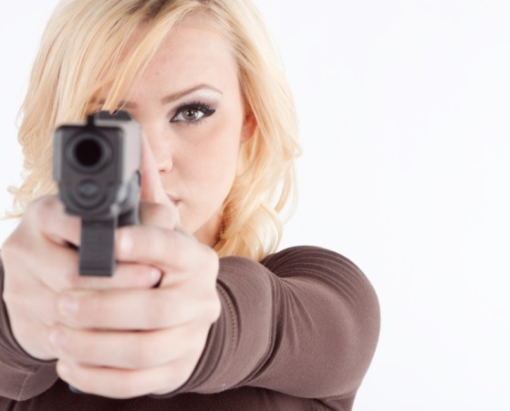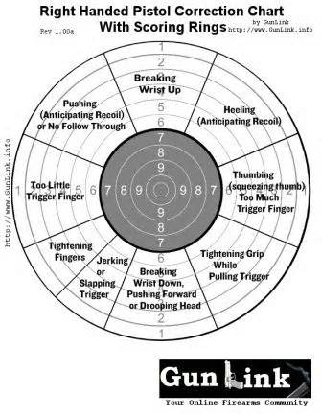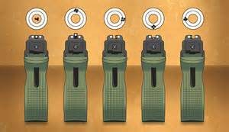
Who: This Clinic is open to Military, Civilians and their Friends. Class size is limited to 30 people. Sign Ups: In order to reserve a seat for the class, you must complete the Electronic Registration Form on the Santa Margarita Gun Club website at www.smgunclub.org. First come, First Served!
What: This clinic is geared towards beginning shooters interested in Competitive Pistol Shooting and Service required Qualification shooting. You will learn the Fundamental Pistol Marksmanship Skills for bullseye and silhouette target shooting from Distinguished Military and Police Pistol Shooters. The class will teach both: one-handed shooting for NRA bullseye matches and two-handed shooting for silhouette target matches. USMC Table 2 qualification course of fire will also be discussed. LIVE FIRE will also be included in this Clinic after the Pistol EIC Match.
When: SUNDAY – November 20, 2016 - from 0800 hours (8:00 AM) until 1200 hours (12:00 PM/NOON). A CMP Pistol EIC Match (Bullseye Style Shoot) will follow the clinic. A Silhouette Pistol Shooting Practice will follow after the Pistol EIC Match. (CMP Pistol EIC Match sign-ups are separate from this pistol clinic. Those also wishing to shot in the EIC Match will be required to sign up for that event.)
Where: Classroom instruction will be conducted at Range 116A aboard MCB Camp Pendleton.
Cost: The cost will be $20.00 per person.
Sign Ups: In order to reserve a seat for the class, you must complete the Electronic Registration Form on the Santa Margarita Gun Club website at www.smgunclub.org AND Submit your payment with signed registration forms to the Club’s Post Office Box @ SMGC P.O. Box 79363 Corona, CA 92877-0178. Questions can be emailed via the club’s Pistol Director – Ted Falencki: onthejobto@aol.com
Sign up today to be sure and get a seat for this fun and informative class!!!

