NRA High Power “Across the Course” Clinic

Specializing in Teaching XTC Techniques to Service Rifle

(AR & M1A) and Match Rifle Shooters

The Santa Margarita Gun Club (SMGC) on Marine Corps Base Camp Pendleton, California is proud to sponsor this Event. This is one of the few opportunities where you will get one-on-one instruction from unique professionals to improve your marksmanship abilities with a Service or Match Rifle.

- DATES: (2 Days) Saturday & Sunday, JANUARY 31 – FEBRUARY 1, 2015

- SPONSORING ORGANIZATION: Santa Margarita Gun Club, Inc.

- Featured Instructors are (2) National Rifle Champions:

Eric T. Swearingen & Harry D. Harrison
2010 National Service Rifle Champion 2000 National Service Rifle Champion
2010, 2011, 2012, 2014 National Police
Match Rifle Champion

Both are accomplished shooters and Marksmanship Instructors, besides being Former National Champions. You can review the rest of their other credentials at the end of this clinic program.

- RIFLE RANGE LOCATION: Range 103, Wilcox Range Complex, MCB Camp Pendleton, CA. Refer to SMGC web-site (www.smgunclub.org) for Camp Pendleton vehicle entry requirements and detailed driving directions to the range.

- RANGE FACILITIES:
Range 103 is a 140-point firing range. It is highly recommended that you bring bottled drinks (non-alcoholic) and/or non-perishable food items. There are no food or drink facilities. Alcoholic beverages are not permitted on or in the general vicinity of the firing lines, while live fire is being conducted. Sanitary facilities are of the “Port-a-Potty” variety.

- EQUIPMENT RULES: Current National Rifle Association (NRA) High Power Rifle Rules will apply.

- OPEN TO: All citizens and legal residents of the United States of America. Citizens of foreign nations may enter this Clinic upon proof of legal entry into the USA (validated passport and/or visa). Membership in the National Rifle Association, Civilian Marksmanship Program or California Rifle & Pistol Association is not required; however, Membership in the Santa Margarita Gun Club is required due to USMC range usage agreements and Insurance Restrictions. This Clinic will be geared towards NRA Marksman and above level shooters.

Those persons who cannot legally participate in the shooting sports or who cannot enter a federal military reservation are not eligible to participate in this event.

Participation DOES NOT and WILL NOT automatically authorize entrance onto MCB Camp Pendleton, CA.
To ensure authorized entry onto the base, eligible participants must ensure you do the following:

- Possess a Department of Defense Vehicle Sticker authorizing you to enter the military instillation OR
- Pre-enter the clinic desired utilizing the Electronic Entry forms on the club’s web site AND
- Have in your possession the following items:
  - Valid Driver’s License and or other picture Identification
  - Current Vehicle Registration
  - Current Proof of Vehicle Insurance
- Complete the Electronically Advance Entry into the scheduled Clinic.

- REGISTRATION FEES & EVENT FEES:

All participants are required to be SMGC Members due to USMC range usage agreements and Insurance Restrictions. If you are not an annual SMGC member already, an assessment of $50.00 is included for the Annual Associate SMGC Membership in the entry fee (This Fee is a $10.00 discount from the Annual Cost for SMGC Associate Membership).

Annual SMGC membership must be confirmed through possession of a valid membership card, or confirmation of participant inclusion in the official membership roster at the morning of registration.

SMGC Regular Membership is open to all Active Duty Members, Reserve Members and Retirees of the United States Armed Forces. Annual SMGC Regular Civilian Memberships are dependent upon the number of Current Military members of the Club, according to the club’s BYLAWS.

ENTRIES - Electronic: ALL ENTRIES ARE REQUIRED IN ADVANCE. Entries can be made by registering for this event on the SMGC Website: (www.smgunclub.org). Registration clinic forms must also be completed in their entirety. NO WALK UP ENTRIES WILL BE ALLOWED on the days of this event.

Dead Line for Entries: Tuesday - January 20th, 2015.

MCB Camp Pendleton Security Regulations require the clinic sponsor (SMGC) notify the appropriate Base agency of Non Department of Defense (DoD) persons participation in the Clinic on the Wednesday preceding the Clinics. This notification is generated by the received clinic entry forms and intention to enter messages. Therefore entry onto MCB Camp Pendleton may be denied to those persons who do not indicate their intent to participate or observe using the electronic Clinic Pre-Registration form. Additionally, persons who have expired driver’s licenses will not be granted entry onto Camp Pendleton.

- CLINIC ENTRY FEES: SMGC Members: $ 100.00
Daily SMGC Members: $ 150.00
Military SMGC Members: $ 50.00 (50% Discount)

Make Checks Payable to: “Santa Margarita Gun Club”
Entry Forms & Fees can be Mailed to: SMGC
P.O. Box 79363
Corona, CA 92877- 0178
- ENTRY LIMIT: 60 Individual Entries.

- RIFLE CLINIC START TIMES: 8:00 AM on Saturday and 8:00 AM on Sunday.

- CHECK-IN PROCEDURES:
All participants must check in at the Clinic processing by 7:30 AM on both mornings of the event.
Participants are required to complete administrative processing, ensure payment of event fees, and receive their squadding assignments before they can participate.

- MANDATORY RANGE SAFETY & ENVIRONMENTAL BREIFING:
Prior to any live rounds being fired, all participants must attend the mandated range safety and environmental briefing. Participants not attending the mandated briefing will not be allowed to participate in the live fire exercises.

- TARGET PULLERS: Participants will be required to pull targets.

- TARGETS: Official NRA Targets will be used in the rifle clinic.

- PARTICIPANT PARKING AREAS: (Range 103) - Participant parking is permitted in the designated dirt parking lot. ALL Participants are required to park their vehicles in this dirt parking lot, adjacent to the east side of the range.

- SAFETY EQUIPMENT: Hearing Protection, Eye Protection, and Empty Chamber Indicators (ECI) are mandatory. ECI’s may be purchased at the range for a cost of $ 2.00.

- OTHER EQUIPMENT: Cloth, canvas or leather shooting jackets may be used. Standard military-issue web or leather slings or slings of this same type are permitted. Shooting gloves or mitts, ground cloths or shooting mats may be used. Shooting kits may be placed on the firing line provided they are not forward of the Participant or the firing line and do not interfere with other participants. Refer to the EQUIPMENT LIST RECOMMENDED Page for further details of all gear needed.

- RIFLE TYPES ALLOWED: NRA Service Rifles (Rule 3.1(e) and 3.7 applies). Match Rifles (and their variations) are also welcome in the clinic. This Clinic is designated to teach techniques specifically targeted towards NRA & CMP Rifle Competitions.

Service Rifles are limited to M16A2 & AR Type Rifles and M1A Rifles. (M1’s are also a service rifle; however, for this clinic they are not the most suitable rifles for working on the reloading drills we will cover.) M16A___ Military Rifles (M4’s) and there Variations (RCO’s) etc. are also welcomed.

- AMMUNITION: Participants must supply their own ammunition. 200 rounds of ammunition are required. Any safe center-fire ammunition, up to and including 7.62mm (.308 caliber), may be used. Tracer, incendiary or armor piercing ammunition is prohibited (Rule 3.17(b) applies).

- TOPICS: During Clinic (Not necessarily in order)

Fundamentals of Rifle Marksmanship -
(Request all attendees to view) the “Fundamentals of Rifle Marksmanship 1999 U.S. Marine Corps” (Video on You Tube 16:49 minutes) It’s old and a bit outdated for NRA Competition, but covers some important details all shooters should know.

Zeroing Process for the Service Rifle
NRA Courses of Fire
800 Regional Match Course
500 NMC – National Match Course
CMP Course of Fire:
EIC – Excellence in Competition
NTI – National Trophy Individual Match
President’s 100
ITT- Infantry Trophy Team Competition (Overview)
Mental Aspects of Shooting:
“How we won the National Rifle Championship”
Firing Positions:
Standing
Sitting
Rapid Fire Prone
Slow Fire Prone
Practical Application - Practice Firing in Positions
Slow Fire Drills
Rapid Fire Drills
Distinguished Rifleman Program – What is required to become a “Distinguished Rifleman”

For Further Information E-Mail Your Questions to: hdharrison@sbcglobal.net

- Recommended Equipment:

Shooting Clothing
Sunglasses
Glasses, prescription (If needed)
Hat / Visor / Boonie Cover
Hearing Protection: Plugs, Over-the-ears (Both Recommended)
Rifle, Service
EIC (empty chamber indicator)
Rifle Sling
Magazines (4), (3 Minimum with 1 which has a single round follower for Slow Fire)
Sight Protectors
Data Book
Tools: Allen Wrenches, Miscellaneous (sight black, etc.)
“Bic Pen” (4 Color Pen) Black, Blue, Red, Green

Ammunition:
100 Yards: 30 rounds
200 Yards Slow Fire 50 rounds (Approx.)
200 Yards Rapid Fire: 80 rounds (Approx.)
300 Yards Rapid Fire: 40 rounds (Approx.)

Shooting Jacket
Shooting Mat
Spotting Scope
Scope Stand
Scope Extensions

Shooting Cart/Stool:
Collapsible Chair (Highly recommended)
Sun Screen
Water
Food/Snack Items:

Notebook with Paper, Various Color Pens, Pencil, etc. for Note Taking

Student Handouts: A Handout will be available to participants at the class. Bringing your own notebook paper for notes is highly recommended.

Emergency Notification Form

(In case of injury and/or serious illness)

Name: ______________________________________________________ Contact Phone # ___________________________________

I certify that the above information is correct. Any misrepresentation may result in disbarment from participation in this Match. I have read the “Release From Responsibility” of this entry form and voluntarily abide by this agreement being fully aware of legal consequences of signing the within instrument.

_________________________________________________ ____________________________________________________ ____________________________
Print Your Name (Signature) (Date)

RELEASE FROM RESPONSIBILITY, WAIVER OF LIABILITY AND ASSUMPTION OF RISK FOR PARTICIPATION IN A DANGEROUS ACTIVITY

FOR AND IN CONSIDERATION of permitting the applicant for Santa Margarita Gun Club Membership, who is named on the reverse side of this form and herein referred to as THE UNDERSIGNED, to enter the MARINE CORPS BASE CAMP PENDLETON AND SANTA MARGARITA GUN CLUB, herein referred to as the “Santa Margarita Gun Club”, premises for the purposes of firearms use, shooting of firearms, observing the shooting of firearms, or any and all other purposes, THE UNDERSIGNED, for himself/herself his/hers heirs, executors, administrators and assigns:
1. Hereby voluntarily releases, discharges, waivers and relinquishes any and all actions or causes of action for personal injury, property damage or wrongful death occurring to the undersigned arising as a result of engaging in or being present at activities at the San Margarita Gun Club premises.
2. Hereby covenants not to sue and voluntarily releases, waivers, discharges and relinquishes any action or causes of action, aforesaid, which may hereafter arise for himself/herself and for his/her heirs, executors, administrators and assigns prosecute or present any claim for personal injury, property damage or wrongful death against MCB, Camp Pendleton, CA, or the Santa Margarita Gun Club or any of its officers, agents, servants or employees for any of said causes of action, whether the same shall arise by negligence of any of said persons or otherwise. IT IS THE INTENTION OF THE UNDERSIGNED BY THIS INSTRUMENT, TO EXEMPT AND RELIEVE THE SANTA MARGARITA GUN CLUB OR ANY OF ITS’ OFFICERS, AGENTS, SERVANTS OR EMPLOYEES; INCLUDING VOLUNTEERS, FROM LIABILITY FOR PERSONAL INJURY, PROPERTY DAMAGE OR WRONGFUL DEATH CAUSED BY NEGLIGENCE.
3. Agrees that in the event any claim for personal injury, property damage or wrongful death shall be prosecuted against the Santa Margarita Gun Club. The Undersigned shall indemnify and save harmless the same Santa Margarita Gun Club and any of its officers, agents, servants or employees, including volunteers, from any and claims or causes of action by whomever or wherever made or presented for personal injuries, property damage or wrongful death.
4. Agrees that the foregoing release is intended to be as broad and inclusive a permitted by the laws applicable in the State of California and that of any portion thereof is held invalid, it is agreed that the balance shall, notwithstanding, continue in full legal force and effect.

5. Acknowledges that the Undersigned has been fully and completely advised of the potential for serious accident incidental to engaging in firearms activities, including the potential for death, personal injury and property damage, and expressly agrees to assume all risks of loss, damage or injury that may be sustained by the Undersigned.
6. This agreement supersedes all previous agreements and shall remain in force until January 31, 2016

DATE: __________________ SIGNATURE: ________________________________________________________

PRINT NAME: _______________________________________________________

SMGC High Power Event Form

(ELECTRONIC ENTRY IS ALSO REQUIRED- FROM SMGC WEB SITE)

www.smgunclub.org

Dates: January 31 – February 1, 2015

This form may be mailed to the Following Address: SGMC, P.O. Box 79363, Corona, CA 92877-0178

DUE BY: January 20, 2015

Name: ________________________________________________________________________ Date of Birth:__________________________

(Last) (First) (Initial) (mm/dd/yyyy)

Address _______________________________________________City _______________________________ State_______ Zip Code ________

Home or Cell Phone _________________________________________ NRA # ____________________________________________________

E-Mail Address _______________________________________________________________________ SMGC Club Member: □ YES □ NO

Squadding Information (Check Appropriate Boxes)

Category: □ Civilian □ Service/Military

Special Categories (optional): □ Grand Senior □ Senior □ Junior □ Woman □ Collegiate □ Police

Rifle Type: □ AR Service Rifle □ M1A Service Rifle □ Match Rifle

NRA XTC HP Classification: □ High Master □ Master □ Expert □ Sharpshooter □ Marksman □ Unclassified

Caliber of Rifle: □ .223/5.56mm □ .308/7.62mm □ .30-06 □ Other: __________

Ammunition: □ Hand Loads □ Factory Ammunition - Lot Number: _______________________________

Fees Schedule (please check the appropriate boxes):

- □ Annual SMGC Members: $100.00

- □ Daily SMGC Members: $150.00

- □ Military SMGC Members: $ 50.00

Rank: ___________________ Service Branch:_______________________________

Instructor’s - Biography Page

Eric Swearingen (SSgt, USMCR):

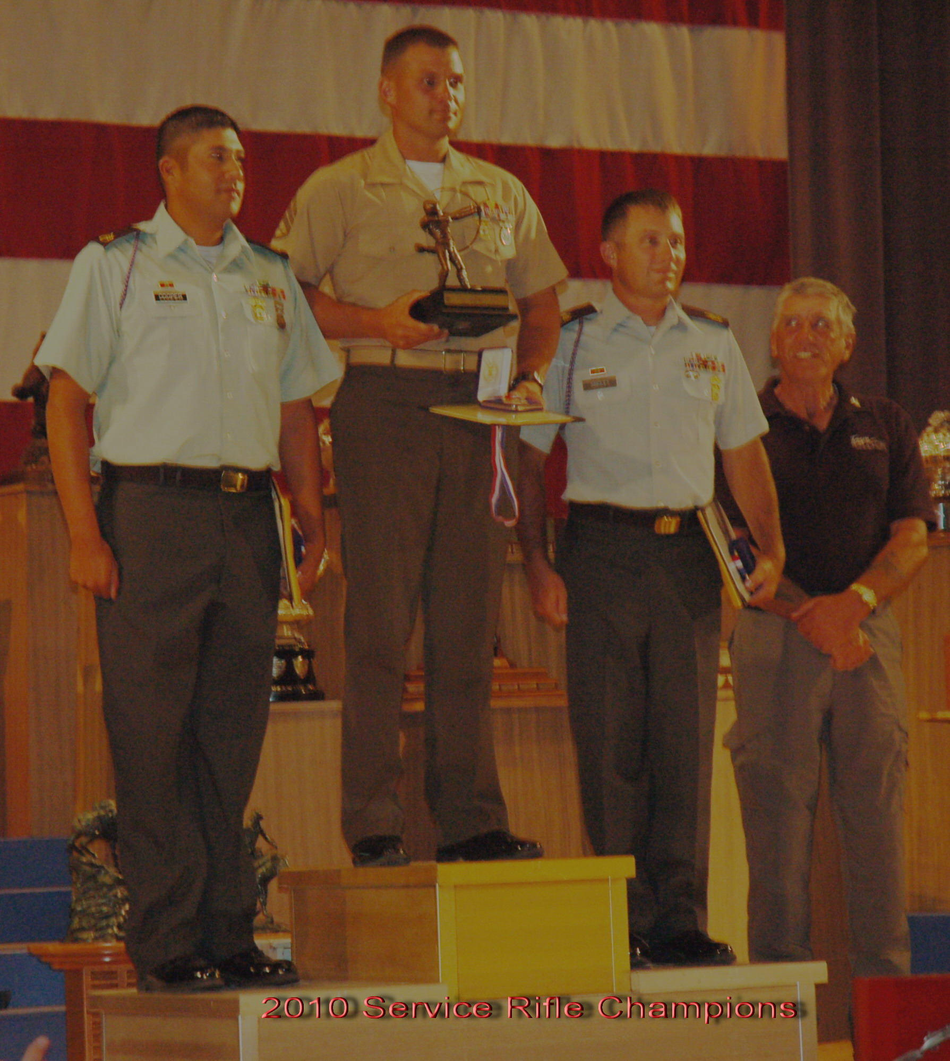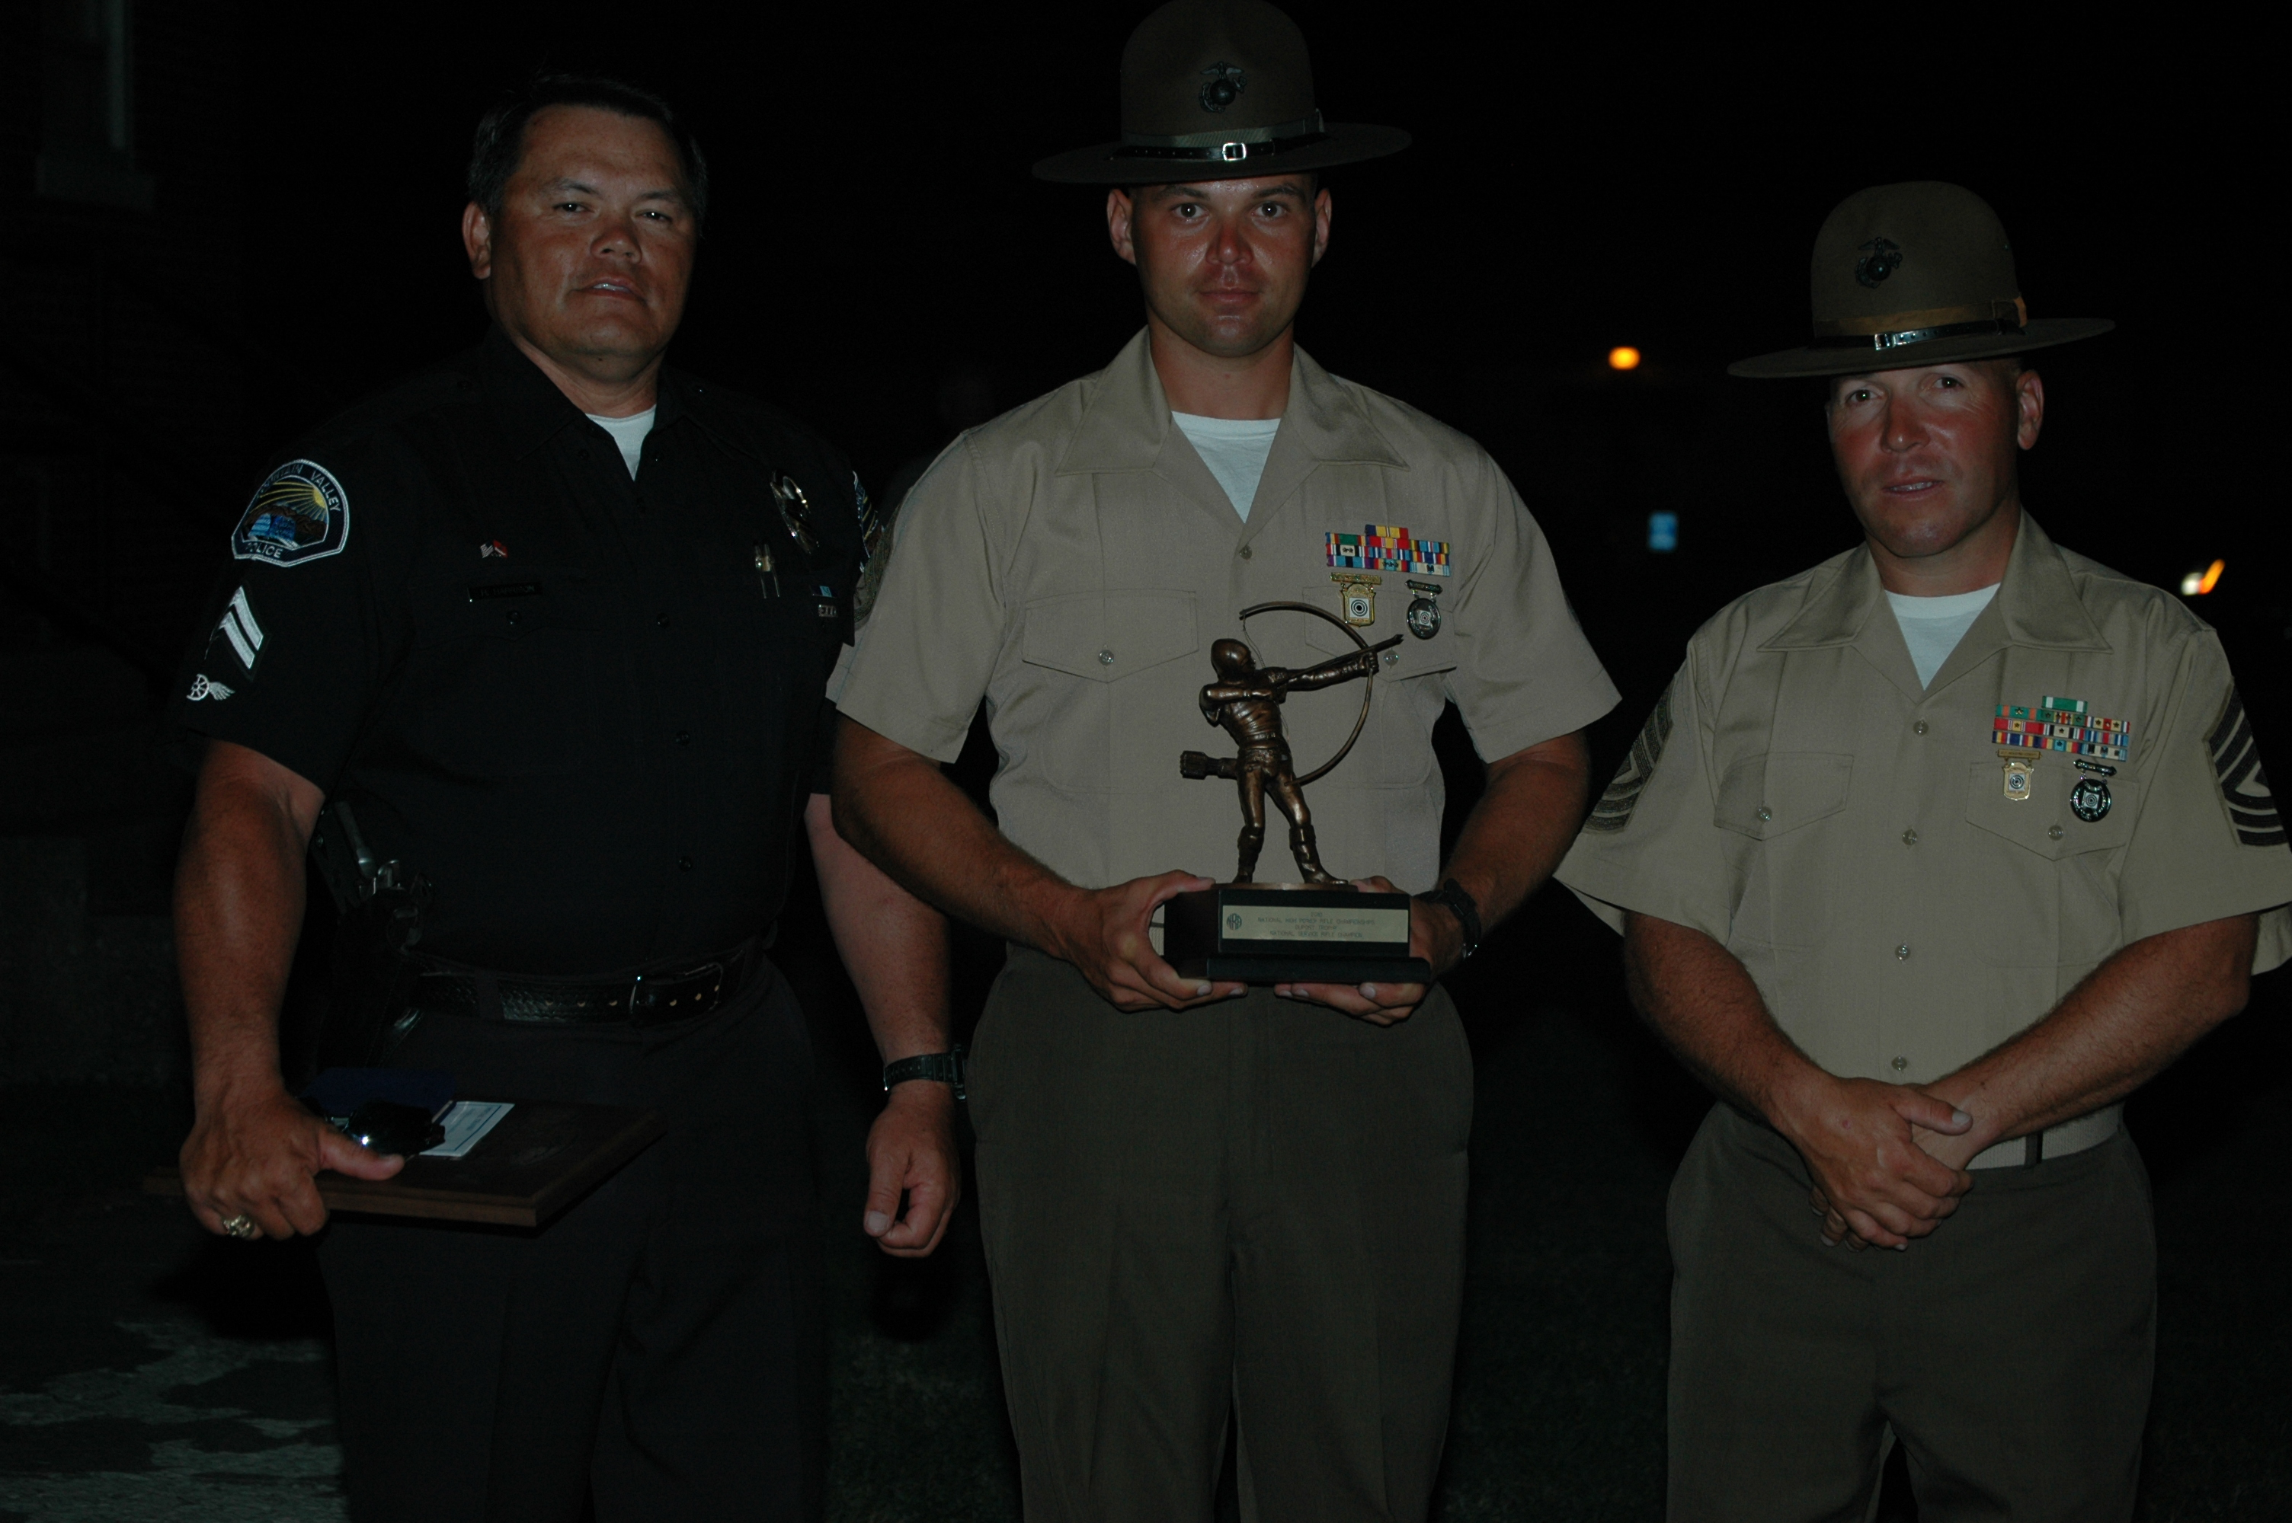

2013 Daniel Boone Trophy
2013 Coast Artillery Trophy
2013 Citizen Soldier Trophy
**** 2010 National Service Rifle Champion ****
2010 Coast Guard Trophy
2009, 2010, 2012 General Smith Trophy
2009, 2010 Hankins Memorial Trophy
2007 Hearst Doubles Trophy, Firing Member
2006 Navy Cup
President’s 100 Member (Numerous Times)
USMC Distinguished Rifleman
NRA National Record Holder in several events
Member of the USMCR National Rifle Team
USMC Combat Marksmanship Trainer

Eric started shooting as a junior coming up through the small-bore program at his local gun club. He first began competitive high power shooting at age 14 and went to the Nation Matches at Camp Perry in 1997. Eric then joined the U.S. Marine Corps in 2001 and spent four years on active duty before going into the reserves. In 2006 Eric was picked up by the Marine Corps Reserve Shooting Team and continues shooting as one of their team members.
Eric is currently a full time college student at San Diego State University where he is pursuing a degree in electrical engineering.
Eric’s fondest memories of shooting are from Camp Perry when he was a junior shooter learning the sport and making life long friends.

Harry D. Harrison (MGySgt, USMCR Retired):

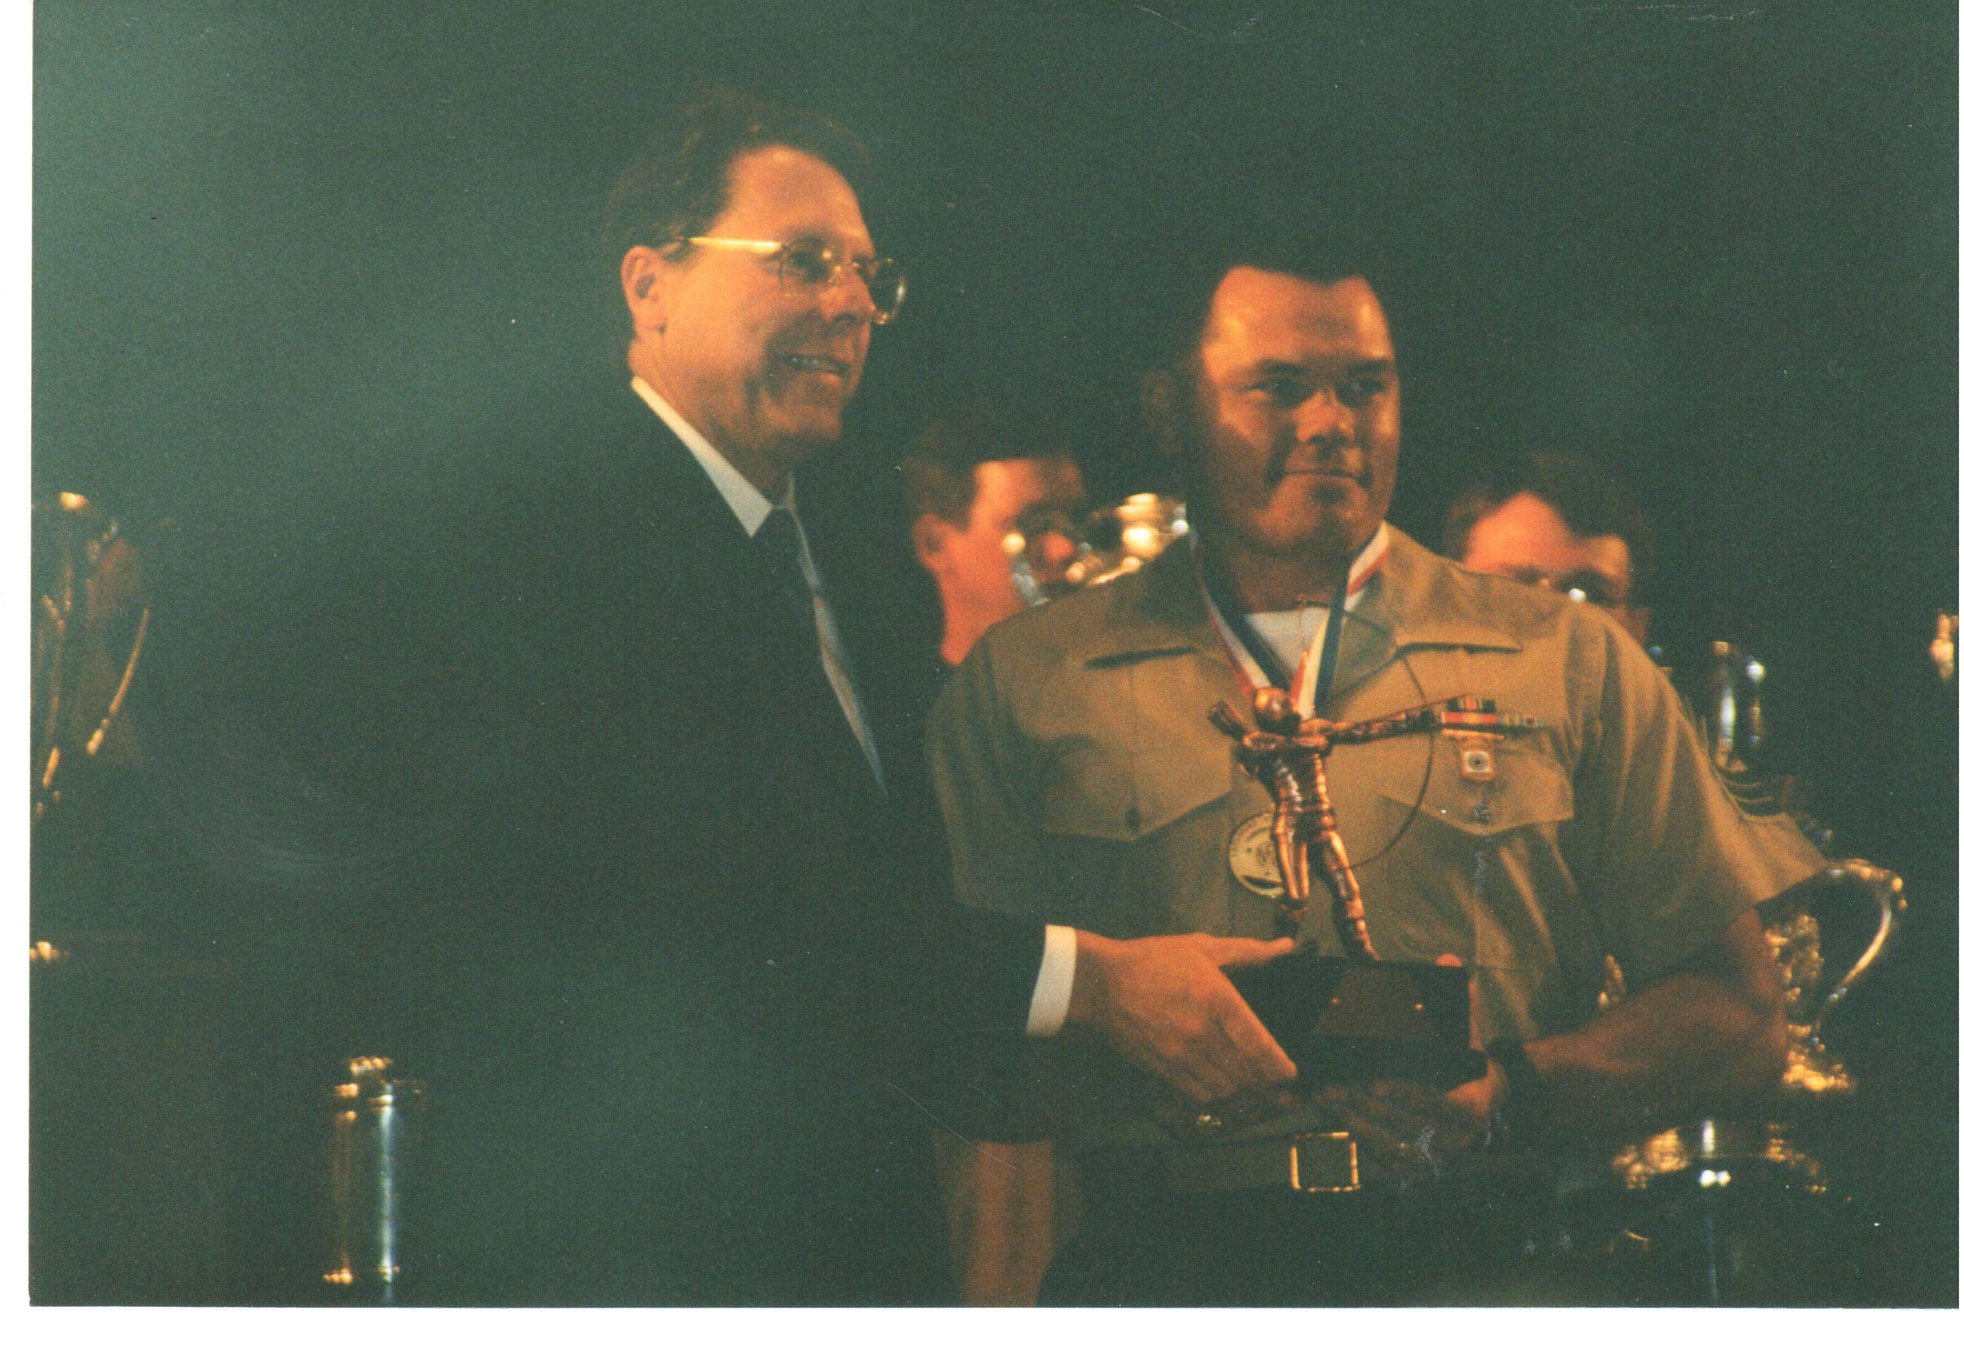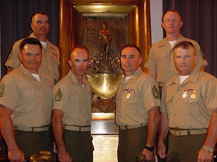

**** 2000 National Service Rifle Champion ****
****2001 National Trophy Team (NTT) National Champions, Firing Member****
****2010, 2011, 2012, 2014 National Police Match Rifle Champion ****
USMC Distinguished Rifleman
NRA Smallbore Prone Distinguished Rifleman
NRA National Record Holder in several events
Former (Retired) Member & Coach of the USMCR Rifle Team (1981-2008)
President’s 100 Member (Numerous Times)
US National Developmental Shooting Team Member
US Dewar Team Member (Top 20 Metallic Sight Smallbore Shooters in the Nation) 1982, 1983
1983 California State Smallbore Prone Champion
1984 Olympic Trials Finalist
1992, 1997 Arizona State Service Rifle Champion
Numerous Wins at Smallbore & High Power Rifle Regionals
United States Police & Fire Championships - Gold, Silver & Bronze Medalist
Western States Police & Fire Championships – Gold, Silver & Bronze Medalist
California Police & Fire Championships - Gold, Silver & Bronze Medalist

Other National Championship Shooting Awards:

2013 Air Force Cup Winner 200 – 17x (Co-Record Holder-Police Category)
2008 Port Clinton Trophy (High Civilian Team in Herrick Match), Team Captain
2001 National Trophy Team (NTT), Firing Member
2001 Hilton Trophy
2000 Hankins Memorial Trophy
2000 General Smith Trophy
2000 DuPont Trophy
1998 The Critchfield-Herrick Trophy, High Service Rifle, Firing Member
1996, 2001 Hilton Trophy, Firing Member
1995, 1998, 2002 Celtic Chieftain Trophy, Firing Member
Instructor Accomplishments:

Huntington Beach Police Department Range Master
USMC Scout/Sniper
USMC Small Arms Weapons Instructor
USMC Combat Marksmanship Trainer
USMC Primary Marksmanship Instructor
NRA Police Firearms Instructor
Santa Margarita Gun Club High Power Rifle Director, Board of Directors, and Club’s Vice President

Harry started his shooting career in 1975 at Norwalk High School as a member of his school’s rifle team. He started shooting competitively in Smallbore in 1975 and in Highpower Rifle in 1979.
He joined the U.S. Marine Corps Reserves in 1978 and Retired as a Master Gunnery Sergeant in 2008.
He is retired Senior Police Officer, Fountain Valley Police Department.
Harry’s most fond Shooting Memory is when his USMCR Rifle Team won the 2001 National Trophy Team (NTT) National Championship. He was a firing Member of that historic team.

